Traffic Control System in the Connected Cars Context

Route Request by user

Authors: Andrei Tudorica(andreitudoricacj@gmail.com)
Document Number: UC02
Version: 0.0.4

Record of Processing
No. | Version | Date | Status | Who | Description
1 | 0.0.1 | 2019-04-20 | First draft. |  | First draft.
2 | 0.0.2 | 2019-04.26 | Updated. |  | Updated.
3 | 0.0.3 | 2019-05-05 | Updated.
4 | 0.0.4 | 2019-05-12 | Done.
5
6
7

Record of Approval
No. | Version | Date | Who | Description
1 | … | … | …
2
3
4
5
6
7

Recipients of Document
No. | Version | Date of Distribution | Recipients
1 | … | …
2
3
4
5
6
7
Table of Contents
1 Allocate Resources 5
1.1 Brief Description 5
1.2 Primary Actor 5
1.3 Stakeholders and Interests 5
1.4 References

. 5
2 Flow of Events 6
2.1 Basic Flow 7

3 Special Requirements 8
4 Preconditions 8

5 Postconditions 8

6 Extension Points

8
7 Technology and Data Variation List 8
8 Open Questions 9

Allocate Resources

- Allocate Resources
  - Brief Description
The purpose of this document is to capture the flow of events that occur when a Traffic Researcher runs a simulation in order to study the effect of the decisions that users take in traffic considering the routes that they know and the routes the Connected Cars Context System generated.
  - Primary Actor
Traffic Researcher.
  - Stakeholders and Interests
Traffic Researcher – interested in studying the effect of the decisions made by Traffic Participants in traffic, using a Simulator.
  - References

Glossary Andrei Tudorica

- Flow of Events

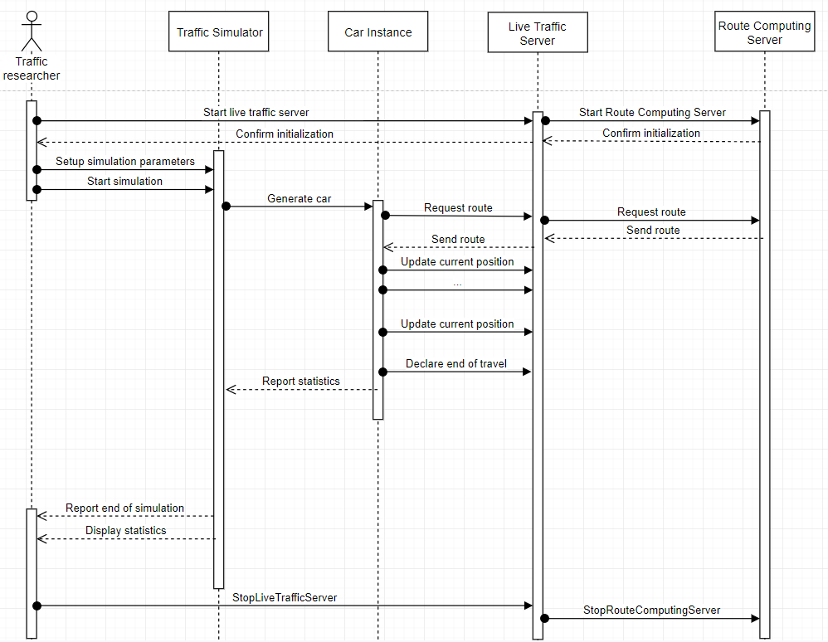

  - Basic Flow

Use-Case Start
This use case starts when the actor starts the Live Traffic Server.

The Live Traffic Server Starts the Route Computing Server.

The Route Computing Server confirms initialization to the LTS.

The LTS confirms initialization to the actor.

The actor starts the simulator and sets up the parameters of the simulation.

The actor starts the simulation.

The Simulator creates car instances that simulate Traffic Participants and request routes from the LTS.

The LTS records the request and requests from the RCS the route request received from the simulator, adding as a parameter the current state of the traffic

.

The RCS responds with the computed route.

The LTS sends the route to the simulated Traffic Participant

The simulated Traffic Participant updates the position over time.

The LTS updates the current state of the traffic based on the updates and requests received from the simulated Traffic Participants

The simulated Traffic Participant declares end of travel.

The LTS reports statistics to the simulator.

The Simulator reports end of simulation to the actor.

The Simulator reports the collected statistics to the actor.

Use-Case End
The actor stops the servers.

- Special Requirements
Not applicable.
- Preconditions
  - The actor

  - has an implemented Simulator.
  - The actor has access to a stand alone copy of the servers, to use for research purposes.
  - The actor knows the parameters of the simulation (routing profiles, weight management)
- Postconditions

All statistics are displayed to the actor.

- Extension Points

Add the Collected Data Processing Server to the flow.
- Technology and Data Variation List
Variation of the simulation parameters.
- Open Questions
Not applicable.

